Exercise 1 – Global Positioning Systems (GPS)

Xu Fei, [feixu12@student.hh.se](mailto:feixu12@student.hh.se)

Qiu Yinan, [yinqiu12@student.hh.se](mailto:yinqiu12@student.hh.se)

**Abstract**

This exercise is mainly about the application Global Positioning Systems(GPS) which we can see it each day and is used for navigating e.g. cars, ships and airplanes.. In this exercise, we will use two sets of data that derived from “NMEA-0183”. The first one is ‘gps_ex1_window2012.txt’, which is a series of GPS positions taken in the same location(static receiver). The histogram that is used to plot the error of position, and the error is follows the Guassian function. The error of position also plot with co-variance matrix which centred around (0, 0) and more than half of the points located in the area of covariance matrix. Auto-correlation is calculated for errors, compare with the auto-correlation on random signal, the difference is obvious for the position data has more similarity than random signal. The other data set ‘gps_ex1_morningdrive2012.txt’ consists of data collected during a regular drive by car within Halmstad. A map of Halmstad is also included as the image file ‘halmstad_drive_area.gif’. The trace is plotted using the data conversion method. Speed and heading of vehicle is calculated and plot against time which shows the measurement of speed is quite accurate and huge difference take place in variance of headings between while the vehicle is driving in low or high speed.

1. **Introduction**

Global Position System is used to provide the location information of something we want to know anywhere on earth or near earth if there’s a GPS receiver. In this report, it is mainly to know how to process the original data that get from the GPS receiver, the Latitude and the Longitude Conversion, Error Estimation and calculate the co-variance matrix. There are two sets of data, one is from static receiver and another is from mobile receiver. In this exercise, all data follows the details of NMEA-0183, a common output of GPS receiver defined by National Marine Electronic Association interface standard and all calculation is operated by using Matlab. Error is estimated by calculate and plot the co-variance matrix and Error of position. Path retracing and speed,heading Analysis of mobile GPS receiver is presented. All exercises is performed in Matlab.

1. **Theory and Method**

In this section, we will introduce the Longitude and latitude conversion, the application of co-variance matrix and auto-correlation for GPS.

* 1. **Longitude and latitude conversion**

The most common ASCII output of any GPS receiver is a set of comma delimited lines (sentences) defined by National Marine Electronic Association interface standard NMEA-0183. Every line follows the same pattern, as shown in the following example[1]:

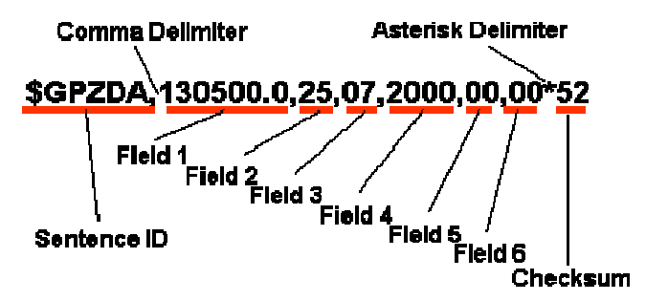

Both the latitude and longitude values included in an NMEA-0183 sentence are presented in degrees, minutes, and decimal minutes. Latitude is presented as ddmm.mmmm, while longitude is presented as dddmm.mmmm in a single field. The direction of latitude and longitude are indicated as a single character in the next field ('N' - north; 'S' - south; 'E' - east; 'W' - west). Most computations that involve geographical coordinates require longitude and latitude to be expressed in decimal degrees with a corresponding sign (negative for south latitude and west longitude) (as shown in the figure below). The conversion of latitude or longitude into decimal degrees is usually done as[1]:

* 1. **Co-variance matrix**

In probability theory and statistics, a covariance matrix (also known as dispersion matrix or variance covariance matrix) is a matrix whose element in the i, j position is the covariance between the ith and jth elements of a random vector (that is, of a vector of random variables). Each element of the vector is a scalar random variable, either with a finite number of observed empirical values or with a finite or infinite number of potential values specified by a theoretical joint probability distribution of all the random variables.[4]

In this report, we use the co-variance matrix to represent the the errors in the x and y position data. In the exercise, the data is two order covariance matrix and used for descibing the variance of position. Actually, the covariance represent the level that two variable affect together. If the variables affect to the output similar, the covariance will be positive, if the variables affect to different direction, the covariance will be negative.

* 1. **Auto-correlation**

Autocorrelation is the cross-correlation of a signal with itself. Informally, it is the similarity between observations as a function of the time separation between them. It is a mathematical tool for finding repeating patterns, such as the presence of a periodic signal which has been buried under noise, or identifying the missing fundamental frequency in a signal implied by its harmonic frequencies. It is often used in signal processing for analyzing functions or series of values, such as time domain signals.[5]

1. **Results and answers**
   1. **Transform Longitude and Latitude Data from Angles to Meters**

First step: Write a function that transform your longitude and latitude angles from NMEA-0183 into degrees. Use the following formula:

$$dd.dddddd=dd+\frac{mm.mmmm}{60}=\left[\frac{ddmm.mmmm}{100}\right]+\frac{ddmm.mmmm-\left[\frac{ddmm.mmmm}{100}\right]×100}{60}$$

The code in matlab can be:

LongDeg = floor(Longitude/100) + (Longitude - floor(Longitude/100)*100)/60;

LatDeg = floor(Latitude/100) + (Latitude - floor(Latitude/100)*100)/60;

Second step: Then process the degrees into meters(use the conversion tables given in the end of the compendium[2]), assume height zero and latitude of 56 degrees. where a = 6378137 m, b = 6356752.3142 m, h – height.The code can be:

X = F_lon * LongDeg;

Y = F_lat * LatDeg;

Figure 3.1 shows the X,Y position in the coordinate system.

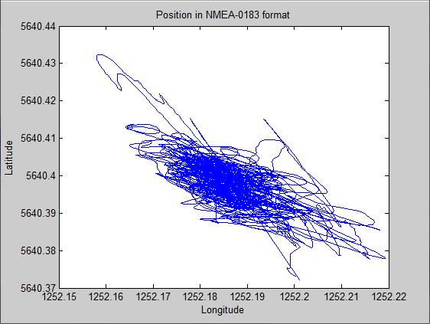

Figure 3.1 X,Y position

* 1. **Estimate the Mean and Variance of the Position (X and Y)**

1. Error

First, calculate the mean value of x and y(the position in the coordinate), and use the original x,y data minus the mean value of x,y to get the error. Then plot the error in histogram form. Use histfit() function to draw the normal Gaussian distribution(red curve in figure 3.2) and compare with error histogram.

Figure 3.2 shows the result.

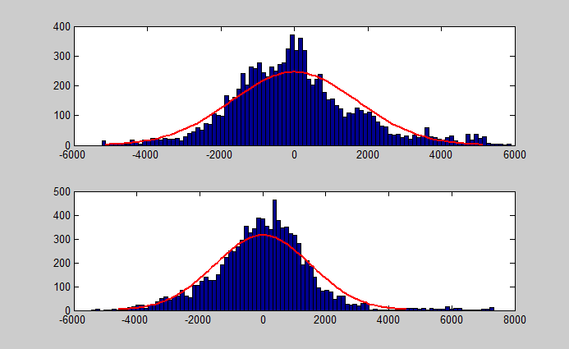

Figure 3.2 Error histogram of x and y

As shown in the figure 3.2, blue column line represent the error of x,y, we can see it clearly that is almost fit the shape of red curve which represent the normal Guassian distribution. Therefore, the error of x,y follows the Guassian distribution. According to the calculation, we found that the maxim error in x is 5.89001, maxim error in y is 7.33283.

1. Co-variance Matrix

Calculate the co-variance matrix of the errors in the x and y position data, in Matlab simply write cov([X Y])if the errors stored in x and y as [N x 1] vectors.

Use the function ‘'plot_uncertainty([0 0]’, cov([X Y]), 1, 2)’ which then plots the co-variance matrix centred around (0, 0). Figure 3.3 shows the result.

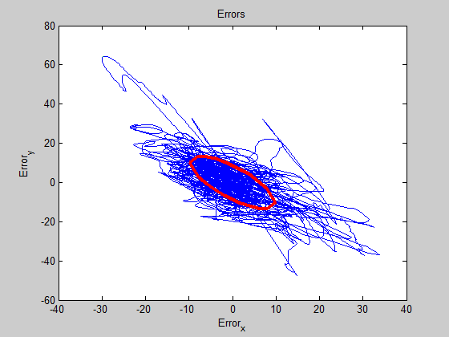

Figure 3.3 Error and co-variance matrix

* 1. **Plot with Respect to time, the Errors and the Auto-correlation in X and Y Separately.**

1. Plot of X and Y

Here, we plot with respect to time, the errors in x and y separately, use Matlab’s function of creating subplots.In figure 3.4, it plot the errors of x and y, the errors of x and y are antithetical, for example at 9000, the error of x is near to 0.5 above the mean value, but the error of y is near to -0.5 below the mean value.

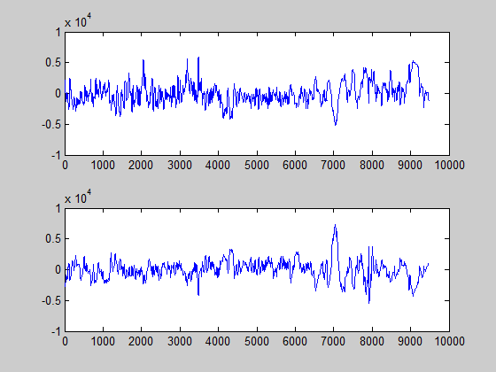

Figure 3.4 errors of x,y position

1. Comparison of Auto-correlation

Here, we plot the auto-correlation of the errors in x and y respectively. Call the function ‘xcorr()’. The result is shown in figure 3.5, the blue line present the auto-correlation of random signal, the red line present the auto-correlation of error in x, the green line present the auto-correlation of error in y.

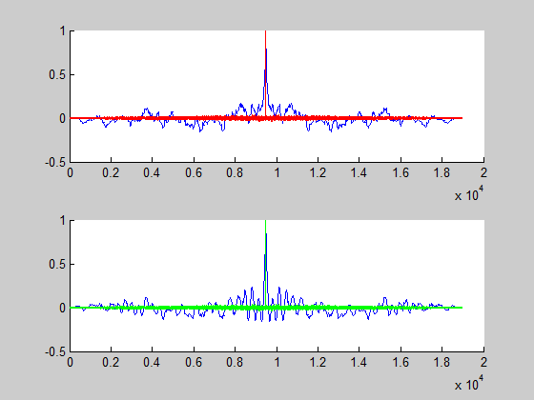

Figure 3.5 Auto-correlation of x and y

From the result, we can see that the auto-correlation of errors in x,y present are much more closed to itself than the random signal. The GPS error is correlated, and it will arrive the peak around about 0.97×104 in abscissa. Compare to the random signal, the GPS errors has more effects when sometime it arrive its peak, but the other time, GPS errors are much more closed to itself than the random signal.It means that the GPS errors will repeat it all the time and it has a time shift for a certain time when it arrive its peak.

* 1. **Mobile GPS Receiver**

1. Plot the Data of Mobile GPS Receiver

Plot the position data (x and y) in the same plot (the path taken by the car) by using the data set ‘gps_ex1_morningdrive2012.txt’, which is collected during a drive on the eastern side of Halmstad. Use the same method as the static GPS receiver to transform the data into meters form.Figure 3.6 shows the path of the car. Figure 3.7 shows that path on the map of a part of Halmstad city.

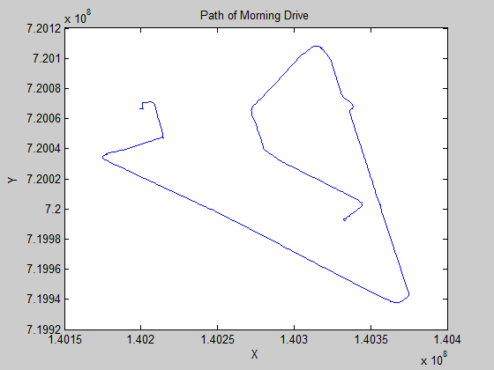

Figure 3.6 Mobile GPS's path

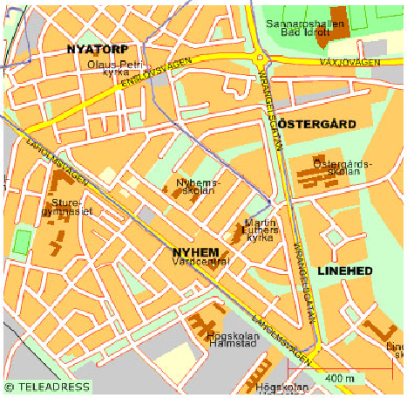

Figure 3.7 Path of driving in east part of Halmstad city

Here, we should resize the map of the part of Halmstad, because we should to make it fit to the plot figure in Matlab, then use plot function to get the trace of the car on the map.

1. Calculate the Speed and Headings of the Vehicle

From the paper we know that the sample rate of GPS receiver is 1Hz, Distance between two points (figure below) can be found using the following formula(λ is longitute, ψ is latitude):

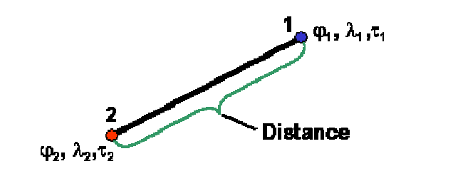

$$Distance=\sqrt{{{(F}_{Lat}(φ_{1}-φ_{2}))}^{2}+{{(F}_{Lon}(λ_{1}-λ_{2}))}^{2}}$$

$$V=\sqrt{V_{x}^{2}+V_{y}^{2}}=\frac{Disatance}{1}$$

Where Vx mean the speed of direction x and Vy mean the speed of direction y, we calculate the speed in separate direction at first then combine them together.

For calculating the heading, we use the following formula:

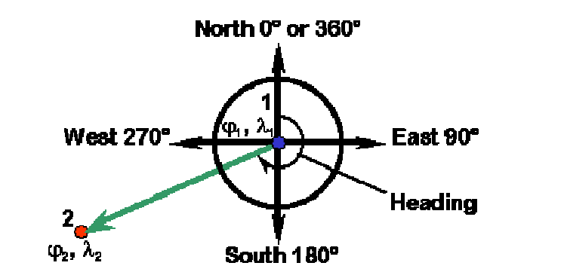

$$if λ_{1}=λ_{2} then Heading={360}^{°} or {180}^{°}$$

$$if λ_{1}<λ_{2} then Heading={90}^{°}-\tan^{-1}\left(\frac{F_{Lat}(φ_{2}-φ_{1})}{F_{Lon}(λ_{2}-λ_{1})}\right)$$

$$if λ_{1}<λ_{2} then Heading={270}^{°}-\tan^{-1}\left(\frac{F_{Lat}(φ_{2}-φ_{1})}{F_{Lon}(λ_{2}-λ_{1})}\right)$$

We use the function 'atan2(Dy,Dx)' in matlab to calculate the heading of the vehicle. Figure 3.8 shows the velocity and heading of the vehicle respect to time.

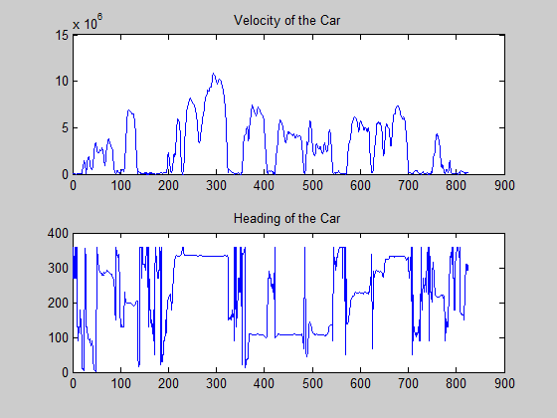

Figure 3.8 speed and heading of the vehicle

According to the figure, because the speed is calculated by the difference between the two points, so the subtraction calculation will eliminate part of the errors, but the position data is obtained directly from the data, so the speed will be more accurate than the position estimation.

We must calculate the error of the heading separately, that means we should divide the whole path into several segments according to every period of the vehicle. Because when the vehicle is in a high-speed and low-speed, the variance vary greatly.For example, when the vehicle driving on Laholmsvägen is approximately 240 to 310, the variance is 1.7632, But when driving on Kyrka with very low speed, the variance is 9.1601e+03. The comparison of the errors is shown in figure 3.9.

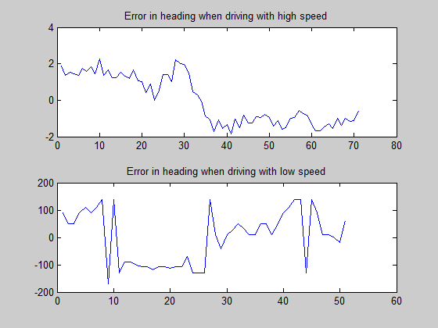

Figure3.9 Error of Heading drive during Laholmsvägen

Because there is errors in static measurement, it's like a uncertain point vibrating, thus when calculating the headings, even every small error can make two adjacent value different and cause large difference in headings. While driving at a high speed, it's like a super large scale compare with the GPS error, thus the error comes less important. The heading will not effect largely by GPS error.

1. **Conclusions and further improvements**

First, this exercise let us understand how the GPS works, learn how to analyze the data that obtain from the GPS receiver and the analytical of errors. In analyze the data, we transform the e original GPS data to the meter form that can be calculated. In analyze error, we learn the relationship between the covariance and the errors in position, and understand how the auto-correlation influence the estimation of the position. Then, in the second part, we use the data obtained by the mobile GPS receiver to do some basic functions of GPS, just like how to calculate of the vehicle speed, vehicle heading and so on.

Further improvements should be made for step forward, for example, more material should be referenced and detail of theory and method should be provide in section 2 and it would be more practical if can access to the data receive section of GPS, in other word, get data on our own and thus will be more data type to analysis.

**Reference**

[1] Global Positioning System Data Processing.

[2] Longitude and Latitude Conversion Table.

[3] Longitude and Latitude Conversion.

[4] <http://en.wikipedia.org/wiki/Covariance_matrix>

[5] <http://en.wikipedia.org/wiki/Autocorrelation>